***(Note: Save the all files you have worked in your computer)***

**Day – 1 & 2**

* Learn HTML concept (1 Day)  
  <https://www.w3schools.com/html/default.asp>
* Create Registration Form with pure html (1 Day)

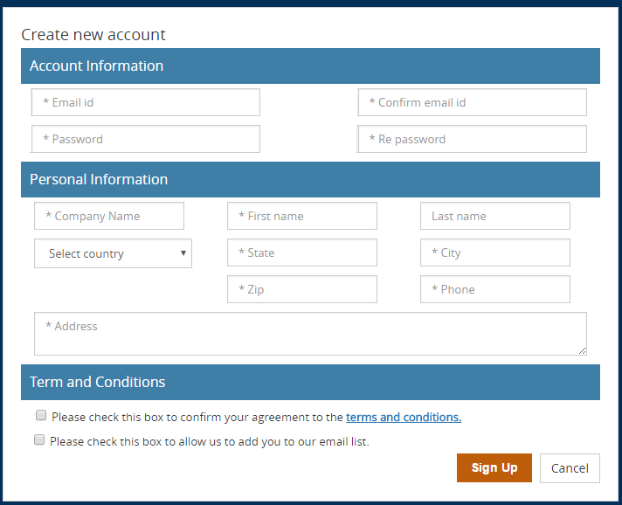

**Day – 3 & 4**

* Learn Bootstrap concept (1 Day)  
  <https://www.w3schools.com/bootstrap/default.asp>
* Create Bootstrap Template (1 Day)

<https://getbootstrap.com/docs/4.0/examples/carousel/>

**Day – 5 to 7**

* Learn CSS concept (1 Day)  
  <https://www.w3schools.com/w3css/defaulT.asp>
* Learn SCSS concept and practice (1 Day)

<https://www.w3schools.com/sass/>

* Registration page design with HTML, CSS, Boostrap (1 Day)

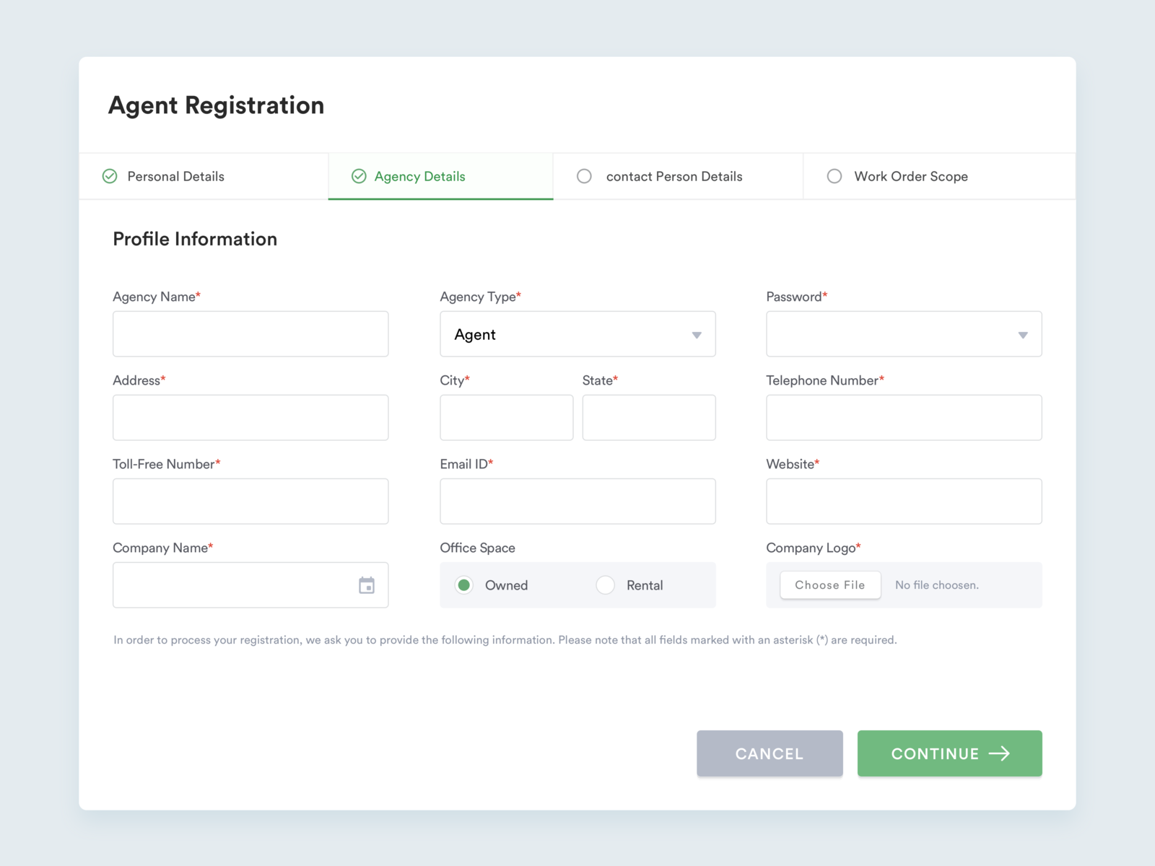

***Practical***

* Try to this page using HTML , Bootstrap, CSS, SCSS, Validation

(Max 3 days)

